RESUME SUITABILITY SCREENER
A Project Report
In partial fulfilment of the requirements for the award of the degree
Bachelors of Computer Applications

Under the guidance of Joyjit Guha Biswas

by
Divyanka Barnwal
Senha Ghosh
Shreyashi Chatterjee

Asansol Engineering College

(ESTD:1998)
Vivekananda Sarani, Kanyapur, Asansol - 713305
Title of the Project: Resume Suitability Screener
Project Members: Divyanka Barnwal
Senha Ghosh
Shreyashi Chatterjee
Name of the guide: Mr. Joyjit Guha Biswas

Project Version Control History:

Version | Primary Author | Description of Version | Date Completed
Final | Divyanka Barnwal  Senha Ghosh  Shreyashi Chatterjee | Project Report | 17th October, 2025

Signature of Team Member: Signature of Approver:

Date:
Mr. Joyjit Guha Biswas
Project Proposal Evaluator

Declaration

We hereby declare that the project work being presented in the project proposal entitled “Resume Suitability Screener” in partial fulfilment of the requirements for the award of the degree of Bachelors of Computer Applications at Asansol Engineering College, Kanyapur, Asansol, is an authentic work carried out under the guidance of Mr. Joyjit Guha Biswas. The matter embodied in this project work has not been submitted elsewhere for the award of any degree of our knowledge and belief.

Date: 17/10/2025

Name of the Student:

Divyanka Barnwal
Senha Ghosh
Shreyashi Chatterjee

Signature of the student:


Asansol Engineering College
Vivekananda Sarani, Kanyapur, Asansol-713305

Certificate

This is to certify that this proposal of minor project entitled “Resume Suitability Screener” is a record of Bonafide work, carried out by Divyanka Barnwal, Senha Ghosh, Shreyashi Chatterjee under my guidance at Asansol Engineering College, Asansol. In my opinion, the report in its present form is in partial fulfillment of the requirements for the award of the degree of Bachelors of Computer Applications and as per regulations of the college. To the best of my knowledge, the results embodied in this report, are original in nature and worthy of incorporation in the present version of the report.
Trainer / Supervisor

Mr. Joyjit Guha Biswas

Contents:

- Overview
- History of Python
- Environment Setup
- Basic Syntax
- Variable Types
- Functions
- Modules
- Packages
- Machine Learning
  - Supervised Learning
  - NumPy
  - Scikit-learn
  - Pandas
  - Classification Analysis
  - Matplotlib
  - Seaborn
  - Streamlit
  - Pickle

- Resume Suitability Screener

Overview:

Python is a high-level, interpreted, interactive and object-oriented scripting language. Python is designed to be highly readable. It uses English keywords frequently where as other languages use punctuation, and has fewer syntactical constructions than other languages.

- Python is interpreted: Python is processed at runtime by the interpreter. You do not need to compile your program before executing it. This is similar to Perl and PHP.
- Python is Interactive: You can actually sit at a Python prompt and interact with the interpreter directly to write your programs.

- Python is Object-Oriented: Python supports Object-Oriented style or technique of programming that encapsulates code within objects.

- Python is a Beginner's Language: Python is a great language for the beginner-level programmers and supports the development of a wide range of applications from simple text processing to WWW browsers to games.

History of Python:

Python was developed by Guido van Rossum in the late eighties and early nineties at the National Research Institute for Mathematics and Computer Science in the Netherlands. Python is derived from many other languages, including ABC, Modula-3, C, C++, Algol-68, Small Talk, UNIX shell, and other scripting languages. Python is copyrighted. Like Perl, Python source code is now available under the GNU General Public License (GPL). Python is now maintained by a core development team at the institute, although Guido van Rossum still holds a vital role in directing its progress.

Features of Python:

- Easy-to-learn: Python has few Keywords, simple structure and clearly defined syntax. This allows a student to pick up the language quickly.
- Easy-to-Read: Python code is more clearly defined and visible to the eyes. Easy -to-Maintain: Python's source code is fairly easy-to-maintain.
- A broad standard library: Python's bulk of the library is very portable and cross platform compatible on UNIX, Windows, and Macintosh.
- Interactive Mode: Python has support for an interactive mode which allows interactive testing and debugging of snippets of code.
- Portable: Python can run on the wide variety of hardware platforms and has the same interface on all platforms.
- Extendable: You can add low level modules to the python interpreter. These modules enable programmers to add to or customize their tools to be more efficient.
- Databases: Python provides interfaces to all major commercial databases.
- GUI Programming: Python supports GUI applications that can be created and ported to many system calls, libraries, and windows systems, such as Windows MFC, Macintosh, and the X Window system of Unix.
- Scalable: Python provides a better structure and support for large programs than shell scripting.

Apart from the above-mentioned features, Python has a big list of good features, few are listed below:
- It supports functional and structured programming methods as well as OOP.
- It can be used as a scripting language or can be compiled to byte code for building large applications.
- It provides very high-level dynamic data types and supports dynamic type checking.
- It supports automatic garbage collections.
- It can be easily integrated with C, C++, COM, Active X, CORBA and JAVA.

Environment Setup:

- 64-Bit OS
- Install Python 3
- Setup virtual environment
- Install Packages

Basic Syntax of Python Program:

Type the following text at the Python prompt and press the Enter –

>>> print "Hello, Python!"

If you are running new version of Python, then you would need to use print statement with parenthesis as in print ("Hello, Python!").
However, in Python version 2.4.3, this produces the following result –

Hello, Python!

Python Identifiers:
A Python identifier is a name used to identify a variable, function, class, module or other object. An identifier starts with a letter A to Z or a to z or an underscore (_) followed by zero or more letters, underscores and digits (0 to 9). Python does not allow punctuation characters such as @, $, and % within identifiers. Python is a case sensitive proming language.

Python Keywords:
The following list shows the Python keywords. These are reserved words and you cannot use them as constant or variable or any other identifier names. All the Python keywords contain lowercase letters only.

For example:
And, exec, not Assert, finally, orBreak, for, pass Class, from, print, continue, global, raisedef, if, return, del, import, tryelif, in, while else, is, with, except, lambda, yield.

Lines & Indentation:
Python provides no braces to indicate blocks of code for class and function definitions or flow control. Blocks of code are denoted by line indentation, which is rigidly enforced.

The number of spaces in the indentation is variable, but all statements within the block must be indented the same amount. For example –

if True:
print("True")
else:
print("False")

Command Line Arguments:

Many programs can be run to provide you with some basic information about how they should be run. Python enables you to do this with -h −

$ python-h
usage: python [option]...[-c cmd|-m mod | file |-][arg]...

Options and arguments (and corresponding environment variables):

-c cmd: program passed in as string(terminates option list)

-d : debug output from parser (also PYTHONDEBUG=x)

-E : ignore environment variables (such as PYTHONPATH)
-h : print this help message and exit [ etc.]

Variable Types:
Variables are nothing but reserved memory locations to store values. This means that when you create a variable you reserve some space in memory.
Assigning Values to Variables:

Python variables do not need explicit declaration to reserve memory space. The declaration happens automatically when you assign a value to a variable. The equal sign (=) is used to assign values to variables.

counter=10 # An integer assignment
weight=10.60 # A floating point
name="Ardent" # A string
Multiple Assignment:

Python allows you to assign a single value to several variables simultaneously. For example –

a = b = c = 1
a,b,c = 1,2,"hello"

Standard Data Types:

The data stored in memory can be of many types. For example, a person's age is stored as a numeric value and his or her address is stored as alphanumeric characters. Python has five standard data types −
- String
- List
- Tuples
- Dictionary
- Number
Data Type Conversion:

Sometimes, you may need to perform conversions between the built-in types. To convert between types, you simply use the type name as a function.
There are several built-in functions to perform conversion from one data type to another.

0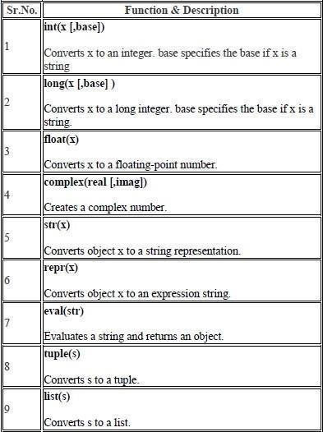

Functions:

Defining a Function:

def function_name(parameters):
"""Docstring"""
# body of the function
return expression

Pass by reference vs Pass by value:

All parameters (arguments) in the Python language are passed by reference. It means if you change what a parameter refers to within a function, the change also reflects back in the calling function. For example –

# Function definition is here

def changeme(mylist):
"This changes a passed list into this function"
mylist.append([1, 2, 3, 4])
print "Values inside the function: ", mylist
return

# Now you can call changeme function

mylist = [10, 20, 30]
changeme(mylist)
print "Values outside the function: ", mylist

Here, we are maintaining reference of the passed object and appending values in the same object. So, this would produce the following result –

Values inside the function: [10, 20, 30, [1, 2, 3, 4]]
Values outside the function: [10, 20, 30, [1, 2, 3, 4]]

Global vs. Local variables
Variables that are defined inside a function body have a local scope, and those defined outside have a global scope. For Example-
total = 0 # This is a global variable.
# Function definition is here
def sum(arg1, arg2):
"""Add both the parameters and return them."""
total = arg1 + arg2 # Here total is a local variable.
print("Inside the function local total:", total)
return total
# Now you can call sum function
sum(10, 20)
print("Outside the function global total:", total)
When the above code is executed, it produces the following result −
Inside the function local total: 30
Outside the function global total: 0

Modules:

A module allows you to logically organize your Python code. Grouping related code into a module makes the code easier to understand and use. A module is a Python object with arbitrarily named attributes that you can bind and reference.
The Python code for a module named a name normally resides in a file named aname.py.

Here's an example of a simple module, support.py

def print_func(par):
print("Hello:", par)
return

The import Statement
You can use any Python source file as a module by executing an import statement in some other Python source file. The import has the following syntax –
import module1[, module2[,… moduleN]

Packages:

A package is a hierarchical file directory structure that defines a single Python application environment that consists of modules and sub packages and sub- subpackages, and so on.

Consider a file Pots.py available in Phone directory. This file has following line of source code −

def pots():
print "I'm Pots Phone"

Similar way, we have another two files having different functions with the same name as above –

Phone/Isdn.py file having function Isdn() Phone/G3.py file having function G3()
Now, create one more fileinit.py in Phone directory − Phone/ init.py
To make all of your functions available when you've imported Phone, you need to put explicit import statements in init .py as follows −
from Pots import Pots from Isdn import Isdn from G3 import

NumPy:

NumPy is a library for the Python programming language, adding support for large, multi-dimensional arrays and matrices, along with a large collection of high-level mathematical functions to operate on these arrays. The ancestor of NumPy, Numeric, was originally created by Jim Hugunin.
NumPy targets the Python reference implementation of Python, which is a non-optimizing bytecode interpreter. Mathematical algorithms written for this version of Python often run much slower than compiled equivalents.
Using NumPy in Python gives functionality comparable to MATLAB since they are both interpreted, and they both allow the user to write fast programs as long as most operations work on arrays or matrices instead of scalars.

Scikit-learn:

scikit-learn is a widely used open-source Python library for machine learning. It provides a simple and consistent interface to a broad range of supervised and unsupervised learning algorithms, making it easy to implement predictive modeling, clustering, and dimensionality reduction in Python. It is built on top of NumPy, SciPy, and matplotlib, leveraging their computational and visualization capabilities.

Key Features:

Supervised Learning: Implements algorithms such as linear regression, logistic regression, support vector machines (SVM), decision trees, random forests, and gradient boosting for prediction tasks.

Unsupervised Learning: Offers clustering (k-means, DBSCAN, hierarchical clustering), dimensionality reduction (PCA, ICA, t-SNE), and manifold learning methods for exploring unlabeled data.

Model Selection and Evaluation: Provides tools for cross-validation, hyperparameter tuning (GridSearchCV, RandomizedSearchCV), and performance metrics to evaluate models.

Preprocessing: Includes utilities for feature scaling, normalization, encoding categorical variables, and transforming data to prepare it for machine learning algorithms.

Pipeline and Integration: Supports building reproducible workflows using pipelines, making it easy to chain preprocessing and modeling steps.

Applications:

scikit-learn is used in diverse areas such as finance, healthcare, image recognition, natural language processing, and scientific research. Its simplicity, efficiency, and extensive documentation make it suitable both for beginners learning machine learning and professionals building complex predictive systems.

Pandas:
In computer programming, pandas is a software library written for the Python programming language for data manipulation and analysis. In particular, it offers data structures and operations for manipulating numerical tables and time series. It is free software released under the three-clause BSD license. "Panel data", an econometrics term for multidimensional, structured data sets.

Library features:

  - Data Frame object for data manipulation with integrated indexing.
  - Tools for reading and writing data between in-memory data structures and different file formats.
  - Data alignment and integrated handling of missing data.
  - Reshaping and pivoting of data sets.
  - Label-based slicing, fancy indexing, and sub setting of large data sets.
  - Data structure column insertion and deletion.
  - Group by engine allowing split-apply-combine operations on data sets.
  - Data set merging and joining.
  - Hierarchical axis indexing to work with high-dimensional data in a lower- dimensional data structure.
  - Time series-functionality: Date range generation.

OS: Miscellaneous operating system interfaces.

This module provides a portable way of using operating system dependent functionality. If you just want to read or write a file see open(), if you want to manipulate paths, see the os.path module, and if you want to read all the lines in all the files on the command line see the fileinput module. For creating temporary files and directories see the tempfile module, and for high-level file and directory handling see the shutil module.
Notes on the availability of these functions:
The design of all built-in operating system dependent modules of Python issuch that as long as the same functionality is available, it uses the same interface; for example, the function os.stat(path) returns stat information about path in the same format (which happens to have originated with the POSIX interface).

Extensions peculiar to a particular operating system are also available through the os module, but using them is of course a threat to portability.

All functions accepting path or file names accept both bytes and string objects, and result in an object of the same type, if a path or file name is returned.

On VxWorks, os.fork, os.execv and os.spawn*p* are not supported.

Pickle: Python object serialization

The pickle module implements binary protocols for serializing and de- serializing a Python object structure. “Pickling” is the process whereby a Python object hierarchy is converted into a byte stream, and “unpickling” is the inverse operation, whereby a byte stream (from a binary file or bytes-like object) is converted back into an object hierarchy. Pickling (and unpickling) is alternatively known as “serialization”, “marshalling,” 1 or “flattening”; however, to avoid confusion, the terms used here are “pickling” and “unpickling”.

Operator: Standard operators as functions

The operator module exports a set of efficient functions corresponding to the intrinsic operators of Python. For example, operator.add(x, y) is equivalent to the expression x+y. Many function names are those used for special methods, without the double underscores. For backward compatibility, many of these have a variant with the double underscores kept. The variants without the double underscores are preferred for clarity.
The functions fall into categories that perform object comparisons, logical operations, mathematical operations and sequence operations.

Introduction to Machine Learning:

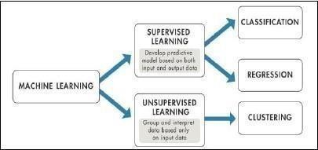

Machine learning is a field of computer science that gives computers the ability to learn without being explicitly programmed.
Evolved from the study of pattern recognition and computational learning theory in artificial intelligence, machine learning explores the study and construction of algorithms that can learn from and make predictions on data.

Machine learning is a field of computer science that gives computers the ability to learn without being explicitly programmed.
Arthur Samuel, an American pioneer in the field of computer gaming and artificial intelligence, coined the term "Machine Learning" in 1959 while at IBM. Evolved from the study of pattern recognition and computational learning theory in artificial intelligence, machine learning explores the study and construction of algorithms that can learn from and make predictions on data

Machine learning tasks are typically classified into two broad categories, depending on whether there is a learning "signal" or "feedback" available to a learning system:-

Supervised Learning:

Supervised learning is the machine learning task of inferring a function from labeled training data. The training data consist of a set of training examples. In supervised learning, each example is a pair consisting of an input object (typically a vector) and a desired output value.
A supervised learning algorithm analyses the training data and produces an inferred function, which can be used for mapping new examples. An optimal

scenario will allow for the algorithm to correctly determine the class labels for unseen instances. This requires the learning algorithm to generalize from the training data to unseen situations in a "reasonable" way.

Unsupervised Learning:
Unsupervised learning is the machine learning task of inferring a function to describe hidden structure from "unlabeled" data (a classification or categorization is not included in the observations). Since the examples given to the learner are unlabeled, there is no evaluation of the accuracy of the structure that is output by the relevant algorithm—which is one way of distinguishing unsupervised learning from supervised learning and reinforcement learning.
A central case of unsupervised learning is the problem of density estimation in statistics, though unsupervised learning encompasses many other problems (and solutions) involving summarizing and explaining key features of the data.

Some Supervised Learning Algorithms are:

Random Forest Classifier:

Random Forest is a versatile and widely used ensemble learning algorithm for classification and regression tasks in machine learning. It builds multiple decision trees during training and combines their outputs to make a final prediction. For classification, it uses majority voting from all trees, while for regression, it averages their outputs. Random Forest helps reduce overfitting compared to a single decision tree and improves accuracy by leveraging the collective decision of multiple models.

How it Works:

- Data Collection: Gather labeled datasets relevant to the problem.
- Data Formatting: Prepare features and target variables, handling missing values and categorical data.
- Model Selection: Select Random Forest and define the number of trees, depth, and splitting criteria.
- Training: Each tree is trained on a random subset of data (bootstrap sampling) and a random subset of features for splitting.
- Testing: The trained model predicts on unseen data, combining predictions from all trees to generate the final output.

Applications:
Random Forest is used in finance (fraud detection), healthcare (disease classification), and e-commerce (customer segmentation) due to its robustness, high accuracy, and ability to handle high-dimensional data.

- K-Nearest Neighbors (KNN):
K-Nearest Neighbors (KNN) is a simple, non-parametric algorithm used for classification and regression. It predicts the class or value of a new data point based on the classes or values of its “k” closest neighbors in the feature space. KNN does not make any assumptions about the underlying data distribution, making it flexible for various problems.

How it Works:

1. Data Collection: Gather labeled datasets with features and corresponding target values.
2. Data Formatting: Scale or normalize features if needed, as KNN uses distance metrics (like Euclidean distance).
3. Model Selection: Choose the value of k (number of neighbors) and distance metric.
4. Training: KNN has no explicit training; it stores the training data for distance comparisons.
5. Testing: For a new data point, find the k nearest neighbors and assign the majority class (for classification) or average value (for regression).

Applications:

KNN is commonly used in recommendation systems, handwriting recognition, and medical diagnosis. It is easy to implement but can but can be computationally expensive when dealing with large datasets because it requires calculating the distance from the new data point to all training samples. Additionally, KNN’s performance can degrade in high-dimensional data due to the curse of dimensionality, where distance measures become less meaningful.
Seaborn:

Seaborn is a Python data visualization library built on top of matplotlib. It provides a high-level interface for creating attractive and informative statistical graphics. Seaborn simplifies complex visualizations by offering built-in themes, color palettes, and functions for common plotting tasks, making it easier to explore and understand data.

Key Features:

- Statistical Plots: Supports plots like bar, box, violin, swarm, and pair plots to visualize distributions and relationships between variables.
- Data Integration: Works seamlessly with pandas DataFrames, allowing direct plotting of columns and grouped data.
- Customization: Offers options to customize styles, colors, and figure aesthetics with minimal code.
- Correlation and Heatmaps: Easily visualize correlations between variables using heatmaps and cluster maps.
- Regression Plots: Includes tools like lmplot and regplot for fitting and visualizing linear regression models.

Applications:
Seaborn is widely used in data analysis, machine learning, and scientific research to explore datasets, detect patterns, and present results in a visually appealing way. Its simplicity and integration with pandas and matplotlib make it ideal for both beginners and professionals.

Streamlit:

Streamlit is an open-source Python framework for building interactive, web-based applications for data science and machine learning. It allows developers and data scientists to quickly create dashboards, visualizations, and prototypes without requiring extensive web development knowledge. Streamlit is designed to be simple, enabling users to turn Python scripts into shareable web apps with minimal code.

Key Features:

- Ease of Use: Build interactive apps using just Python; no HTML, CSS, or JavaScript is required.
- Widgets and Interactivity: Supports sliders, buttons, checkboxes, file uploaders, and more to create dynamic applications.
- Data Visualization: Integrates seamlessly with libraries like matplotlib, seaborn, Plotly, and Altair for interactive charts and graphs.
- Real-Time Updates: Automatically updates the app when the underlying Python script or input changes.

- Sharing and Deployment: Apps can be easily shared locally or deployed on cloud platforms for broader access.

Applications:
Streamlit is widely used in machine learning model demos, data dashboards, business analytics, and educational tools. Its simplicity and interactivity make it ideal for rapid prototyping and presenting results to stakeholders without needing complex front-end development.

How does it work?

- Write a Python script and add Streamlit functions (st.write, st.slider, etc.).
- Run the script using streamlit run your_script.py.
- Streamlit automatically generates a web-based UI.
- Apps are reactive; user interactions trigger script reruns and update outputs.
- Supports integration with visualization libraries (matplotlib, seaborn, Plotly, etc.).
- Apps can be shared locally or deployed to the cloud.

Resume Suitability Screener
Recruitment involves evaluating many resumes to find suitable candidates, which is time-consuming.
This project builds a Resume Suitability Screener system using basic machine learning to automate initial screening.
It analyzes skills, education, and experience to determine candidate suitability.
The model provides basic automation for recruitment tasks. The project includes Streamlit, Machine Learning, Pickle that can improve accuracy in real-world applications.

Here are the steps to create a simple explanation of Resume Suitability Screener:-

- Data Collection:
Gather a dataset of resumes containing various features such as candidate name, skills, experience, education, and job role.
- Data Preprocessing:
Clean and preprocess the data by removing unnecessary text, handling missing values, and converting text-based features into numerical form using techniques like TF-IDF vectorizer.
- Feature Selection:
Identify key features that strongly influence candidate suitability, such as technical skills, experience years, and education level.
- Train-Test Split:
Divide the dataset into training and testing sets to ensure fair model evaluation. The training data helps the model learn patterns, while the testing data measures its performance.
- Model Training:
Apply a machine learning algorithm such as K-Nearest Neighbors (KNN) and Random Forest Classifier to train the model for resume classification.
- Model Evaluation:
Evaluate the model’s performance using metrics like accuracy, precision, and F1-score to determine how well it identifies suitable candidates.
- Model Optimization:
Fine-tune the model by adjusting hyperparameters, improving data quality, or trying advanced techniques like pickle, streamlit for more accurate screening.

Actual codes for Resume Suitability Screener:
Imports:

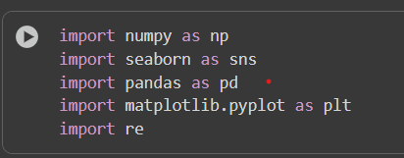

Loads the Dataset:
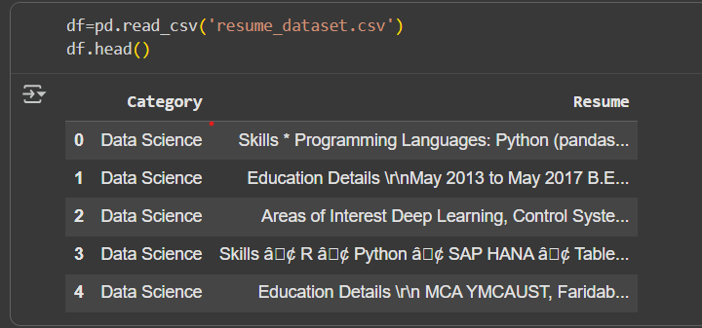

Checking Category Distribution:

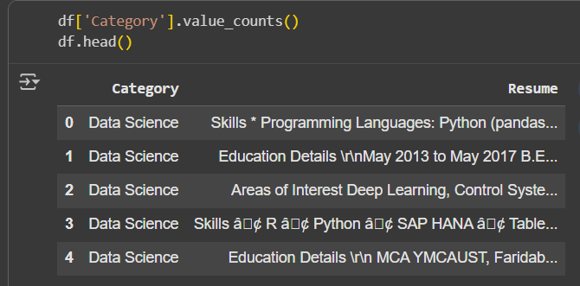

Viewing a sample resume from dataset:
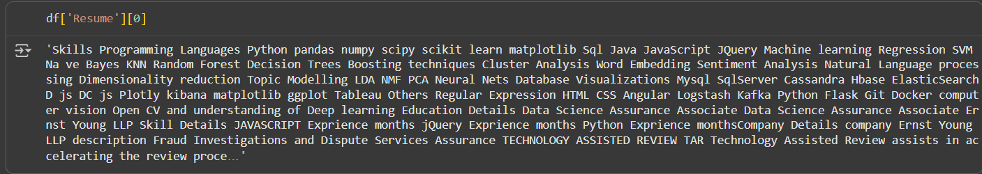

Define a text cleaning function:
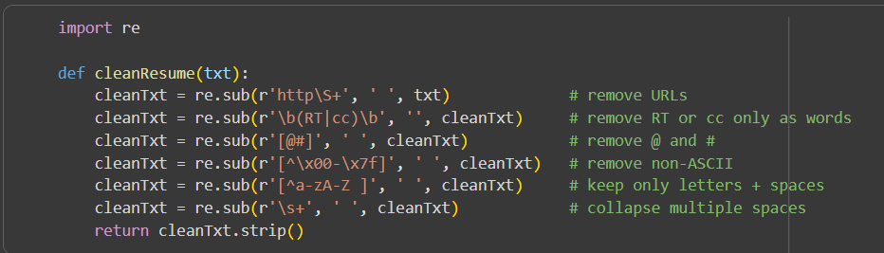

Testing the Cleaning Function:

Cleaning All Resumes:

Viewing a Cleaned Resume:

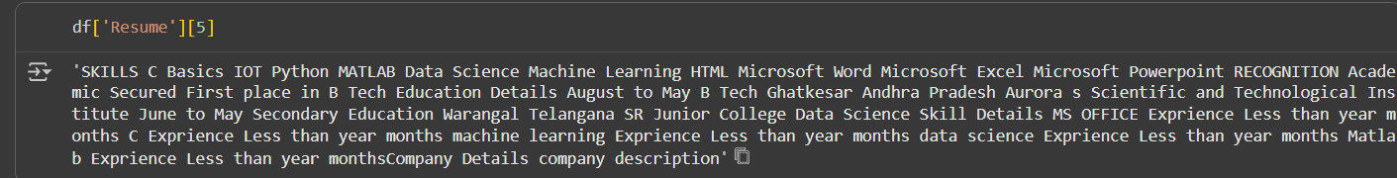

Importing Label Encoder:

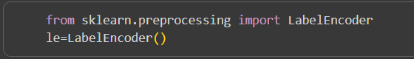

Encoding Categories:

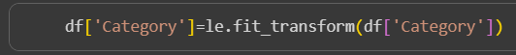
Checking Encoded Categories:

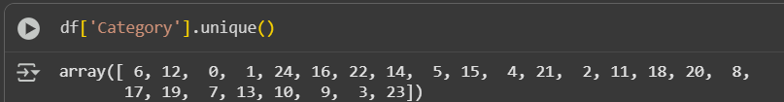

TF-IDF vectorization section:

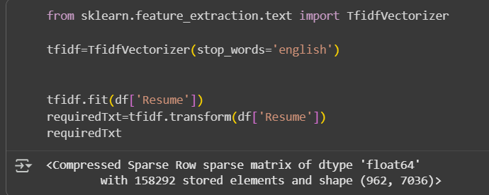

Import Train-Test Split:

Splitting Dataset:

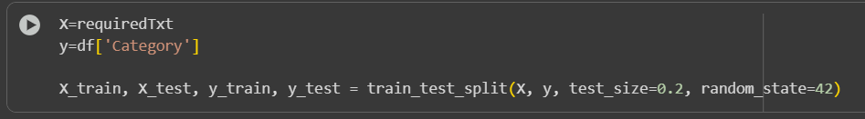

Importing KNN algorithm to train the model:

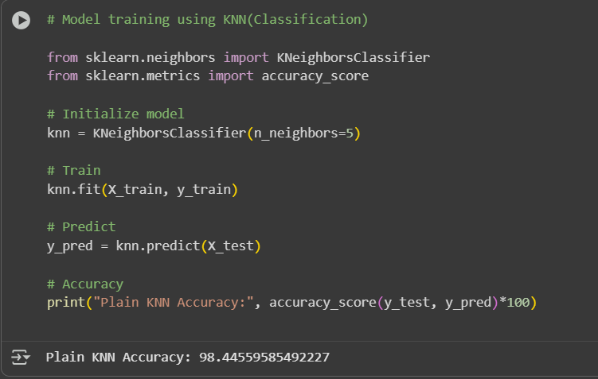

Importing Random Forest Classifier algorithm to check the deviation in accuracy while train the model:
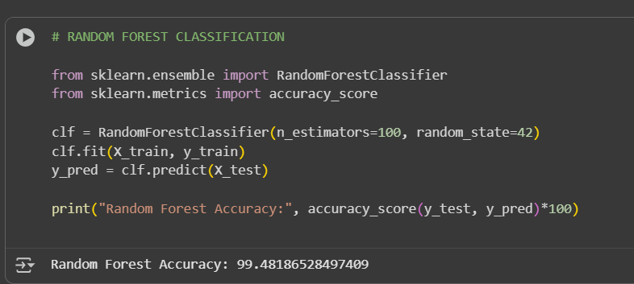
Creating a Sample Resume:
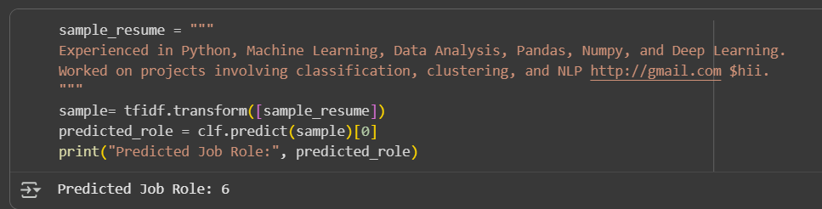

Saving Model and Vectorizer:
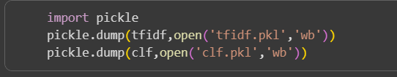

Loading Model and Cleaning Input:
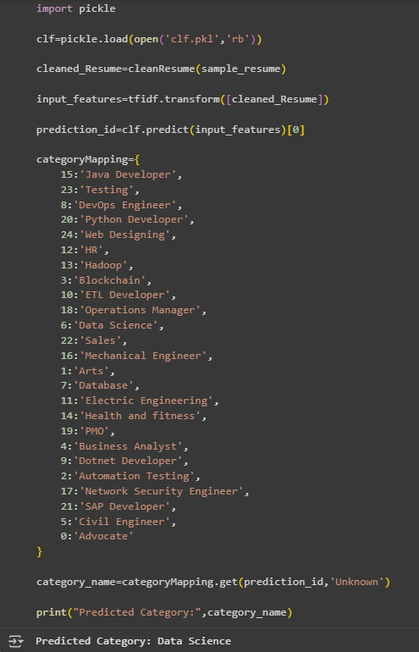

Code for Streamlit UI:
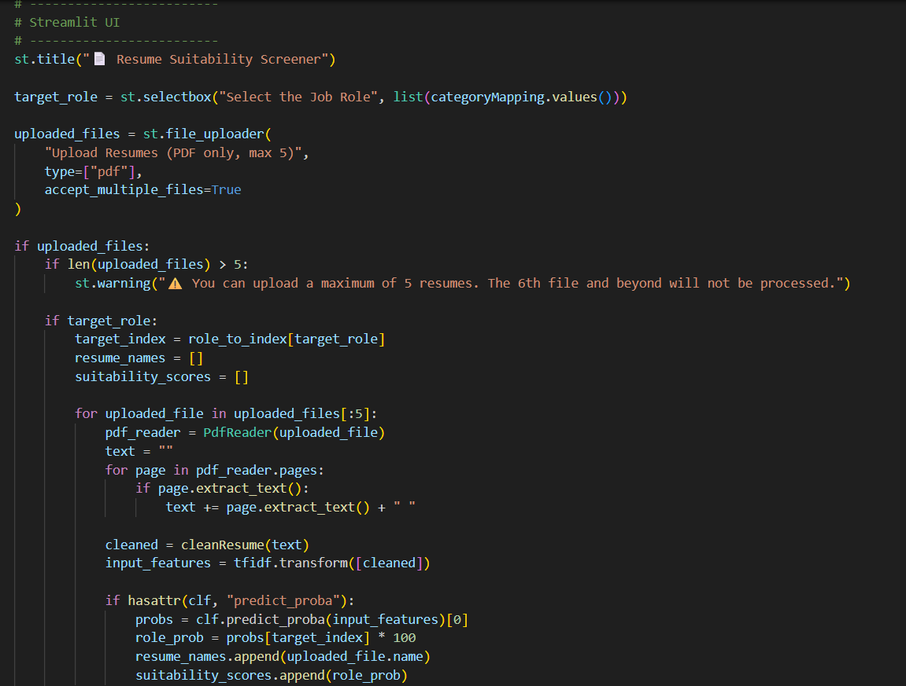

Code for Visualization:
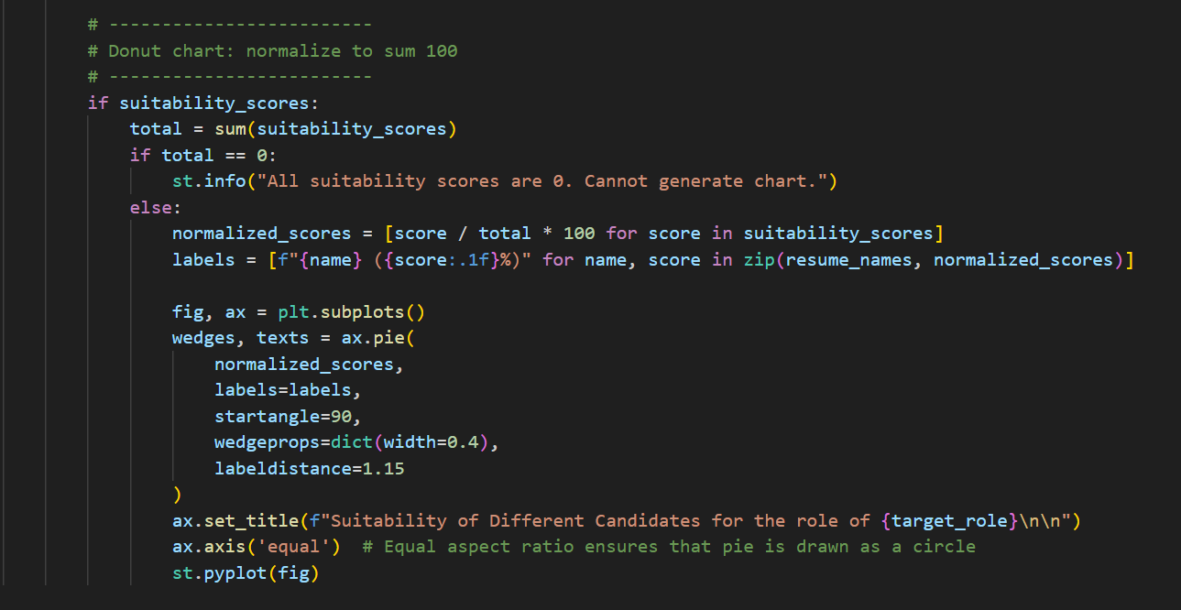
Selection of Job Role from Dropdown Box:
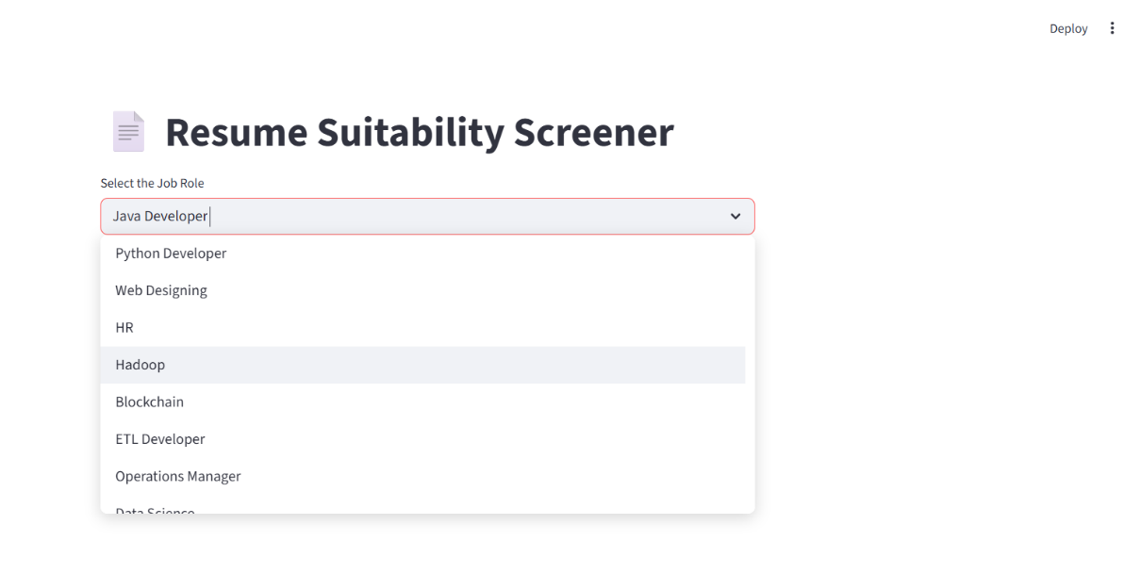

Uploading Resumes for Evaluation:

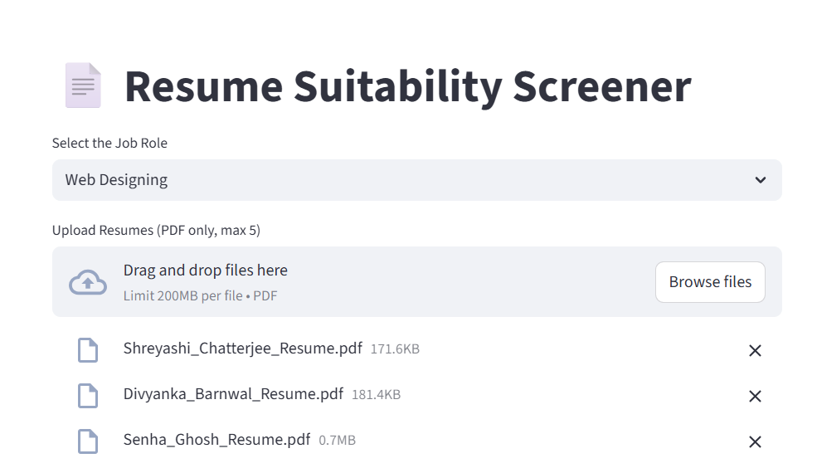

Visualization:

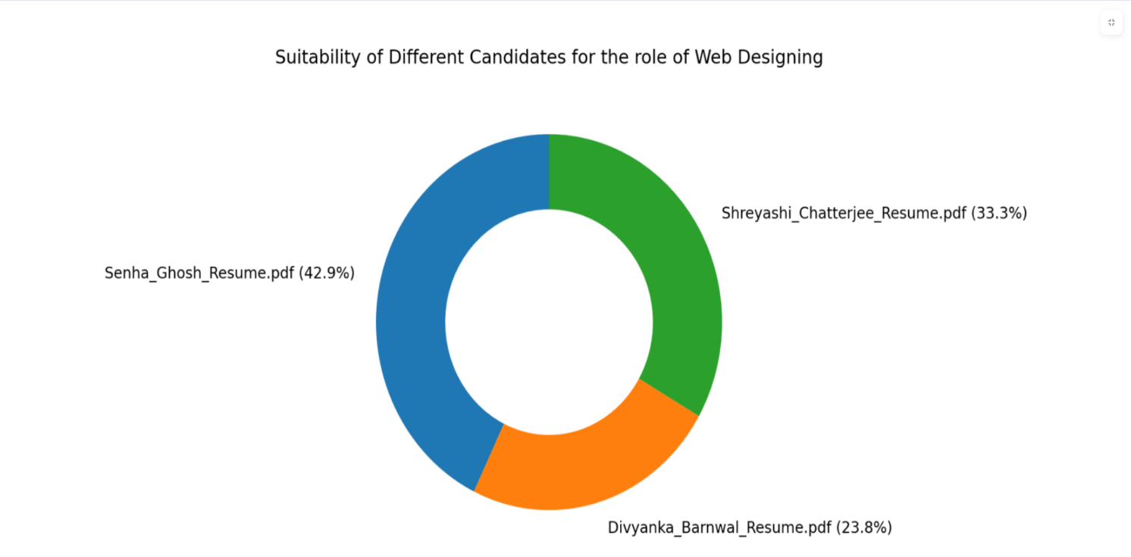

Conclusion

The Resume Suitability Screener is a transformative tool in modern recruitment, bridging the gap between manual resume evaluation and automated, data-driven decision-making. By leveraging machine learning techniques, it systematically analyzes resumes for skills, experience, education, and job-relevant keywords, ensuring that only the most suitable candidates are shortlisted. This not only saves significant time and effort for HR professionals but also reduces human bias, leading to fairer and more objective hiring decisions. Additionally, the system provides insights into candidate strengths and potential fit for a role, helping organizations make informed decisions quickly. With its scalability, the screener can handle resumes in bulk, making it ideal for large-scale recruitment drives, campus placements, and corporate hiring. Overall, this tool enhances the efficiency, accuracy, and transparency of the recruitment process, while allowing recruiters to focus more on strategic evaluation and engagement with top talent.

Future Scope:

- Expand Algorithms: Explore deep learning models (BERT, CNNs, RNNs) for better context understanding beyond Random Forest & KNN.
- Improve Feature Extraction: Move from simple text cleaning + TFIDF to word embeddings (Word2Vec, GloVe, Sentence Transformers) for richer representation.
- Hyperparameter Optimization: Use Grid Search / AutoML to finetune Random Forest and KNN for higher accuracy.
- Scalability: Handle large volumes of resumes efficiently with distributed processing.
- Real-Time Processing: Allow recruiters to upload resumes and get instant screening feedback.
- Integration: Connect with LinkedIn / Job Portals / ATS systems for end-to-end recruitment workflow.
- Explainability: Add model interpretability (feature importance, SHAP values) so recruiters understand why a resume got a certain score.

THANK YOU

